

**AMERICAN INTERNATIONAL UNIVERSITY–BANGLADESH (AIUB)**

**FACULTY OF SCIENCE & TECHNOLOGY**

**REPORT ON INTERNSHIP AFFILIATION AT TRUST BANK**

**ON**

**ENTERPRISE NETWORK FOR BANKING SERVICES**

An Internship Report Presented to the

OFFICE OF PLACEMENT and

DEPARTMENT OF COMPUTER SCIENCE

In Partial Fulfillment of the Requirements for the Degree

***Bachelor of Science in Computer Science and Engineering***

**Supervised By**

**Mohaimen-Bin-Noor**

**Assistant Professor & Special Assistant**

**Submitted By**

**Name: Anika Anjum**

**ID:** **20-41909-1**

Fall 2023-2024

Date of Submission: **January 09, 2024**

# LETTER OF SUBMITTAL

January 09, 2024

Mohaimen-Bin-Noor

Assistant Professor, Computer Science

Faculty of Science and Technology (FST)

American International University-Bangladesh (AIUB)

Subject: Submission of Internship Report on Enterprise Network for Banking Services

Dear Sir,

With all due respect, I would like to let you know that I am doing my Bachelor of Science (B.Sc.) from the Department of Computer Science & Engineering (CSE) of American International University-Bangladesh (AIUB). I am incredibly grateful for the opportunity to complete my internship at IT Division of Trust Bank Limited. Working with IT division, particularly with the Network Team was a remarkable opportunity for me. I believe it will be a great benefit for my professional experience. This report represents the outcome of the skills learned throughout the internship. I made a sincere effort to prepare this report. The majority of the information in this report is based on my knowledge and skills. The IT division was incredibly helpful and communicative. They gave me a heartfelt welcome and treated me like one of their own team members. They have my sincere gratitude. I sincerely hope that you would grant my effort and overlook the tiny mistakes. I appreciate your assistance.

In the report, I have summarized the essential aspects of my internship, including the skills I acquired, the challenges I faced, and my overall experience. I hope that my report proves valuable and engaging to you. I extend my gratitude for your cooperation throughout this internship experience. Your support has been invaluable in facilitating a positive and conducive learning environment. Thank you for your understanding and encouragement.

Sincerely Yours,

Anika Anjum

ID: 20-41909-1

Bachelor of Science in Computer Science and Engineering



Signature

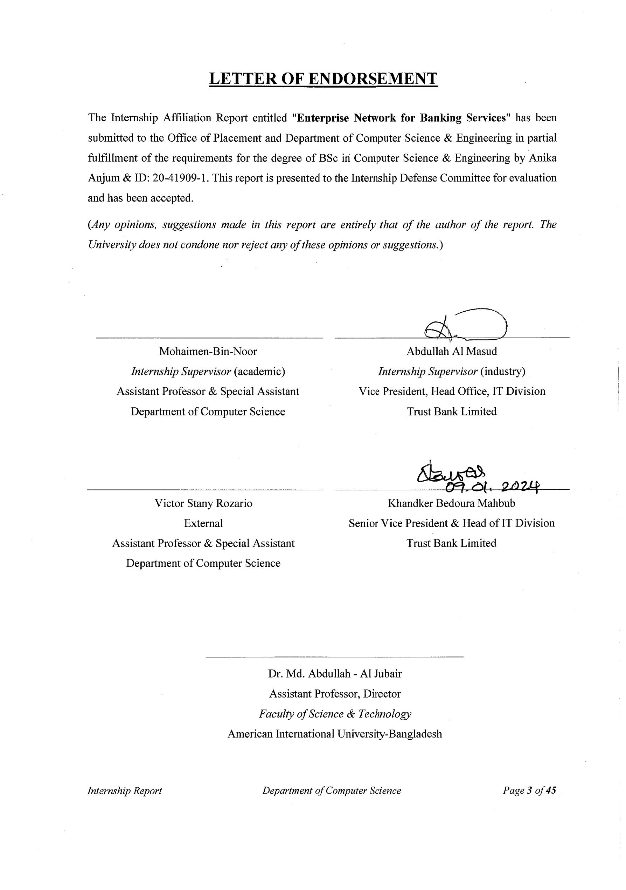

# ACKNOWLEDGEMENT

First of all, I would like to thank almighty Allah, for his grace in accomplishing my internship report timely.

I would like to express my gratitude to the **Faculty of Science & Technology** to keep internship credit in the curriculum of the graduation program and give me a scope of tasting the flavor of industry-oriented tasks and the field of work with my interest. I am also grateful to the **Faculty of Science & Technology & Office of Placement & Alumni**, AIUB to arrange an opportunity for choosing an own interested organization and complete internship there.

Special thanks and appreciation go out to **Khandaker Bedoura Mahbub, Head of IT Division**, Trust Bank Limited.

I extend my heartfelt gratitude to my industrial supervisor, **Abdullah Al Masud, Vice President and Manager, Data Center and Network Operations Center** for his invaluable guidance, unwavering support, and remarkable contribution to the realization of the "Enterprise Network for banking services" project.

Throughout this journey, he guided as an indispensable mentor, offering profound insights and expertise that were pivotal in shaping a comprehensive understanding of the intricate network architecture required for modern banking services. His in depth of knowledge in network infrastructure and our commitment to excellence played a crucial role in translating theoretical concepts into a functional reality.

I would also like to extend my heartfelt thanks to **Rubyat Binte Hassan, Assistant Officer**, my internship coordinator, for her cordial assistance and coordination in managing the various aspects of this project. Also, I appreciate the suitable office hours that allowed me effectively balance my work, education, and personal commitments. Additionally, I want to thank the members of the IT Division, who described different operations of IT Division.

This mentorship not only enriched my understanding of enterprise networking but also empowered me to apply innovative solutions to overcome challenges inherent in such a complex undertaking.

# TABLE OF CONTENTS

|  |  |
| --- | --- |
| **TOPICS** | ***Page no*.** |
| 1. **Title Page** | 1 |
| 1. **Letter of Submittal** | 2 |
| 1. **Letter of Endorsement** | 3 |
| 1. **Acknowledgement** | 4 |
| 1. **Table of Content** | 5 |
| 1. **List of Figures** 2. **List of Tables** | 6  7 |
| 1. **Introduction** | 8 |
| * 1. Rationale | 8 |
| * 1. Background | 8-11 |
| * 1. Objectives | 11 |
| 1. **Activities** | 12 |
| * 1. Work Load | 12-13 |
| * 1. Organization Wide | 13-14 |
| * 1. Other Relevant Activities | 14 |
| 1. **Constraints/Challenges** | 15 |
| * 1. Identified/Observed in the Organization | 15 |
| * 1. Academic Preparation | 15-16 |
| * 1. Personal/Professional Skills | 16 |
| 1. **Project Work** | 17 |
| * 1. Project Overview | 17-18 |
| * 1. Topology Table | 19-33 |
| * 1. Testing Connectivity   2. Future Scope | 34-36  37 |
| 1. **Concluding Statements** | 38 |
| * 1. Summary | 38 |
| * 1. Recommendations/Suggestions for future strategic actions | 38 |
| * + 1. Organization | 38 |
| * + 1. University | 39 |
| * + 1. Personal/Professional | 39 |
| 1. **Recommendation Letters** | 40 |
| 1. **References** | 41 |
| 1. **Appendices** | 42-44 |

**LIST OF FIGURES**

|  |  |
| --- | --- |
| **TITLE** | ***Page no*.** |
| **Figure 1.1 IT Division of TBL** | 9 |
| **Figure 4.1 Enterprise Network for banking services using Cisco Packet Tracer** | 18 |
| **Figure 4.2 GRE Tunnel and OSPF configuration in ORG Dhaka Router** | 24 |
| **Figure 4.3 VLAN configuration in Dhaka Head-Office switch** | 24 |
| **Figure 4.4 DHCP pool and IP configuration in Dhaka Head-Office switch** | 25 |
| **Figure 4.5 VLAN configuration in Floor-2 switch** | 25 |
| **Figure 4.6 VLAN configuration in Floor-3 switch** | 26 |
| **Figure 4.7 GRE Tunnel and OSPF configuration in ORG CTG Router** | 27 |
| **Figure 4.8 GRE Tunnel and OSPF configuration in ORG BOG Router** | 28 |
| **Figure 4.9 VLAN configuration in Server switch** | 29 |
| **Figure 4.10 IP configuration in Server switch** | 29 |
| **Figure 4.11 DNS** | 30 |
| **Figure 4.12 DHCP** | 30 |
| **Figure 4.13 Email Configuration** | 31 |
| **Figure 4.14: Send and Receive Mail Success** | 31 |
| **Figure 4.15 FTP** | 32 |
| **Figure 4.16 Web Page for Green Bank** | 32 |
| **Figure 4.17 CBS Login** | 33 |
| **Figure 4.18 iBanking Login** | 33 |
| **Figure 4.19 Head Office and CTG connection** | 34 |
| **Figure 4.20 Head Office and Bogura connection** | 34 |
| **Figure 4.21 CTG and Head Office connection** | 35 |
| **Figure 4.22 CTG and Bogura connection** | 35 |
| **Figure 4.23 Bogura and Head Office connection** | 36 |
| **Figure 4.24 Bogura and CTG connection** | 36 |

**LIST OF TABLES**

|  |  |
| --- | --- |
| **TITLES** | ***Page no*.** |
| **Table 4.1 Routing table of Head Office** | 19 |
| **Table 4.2 Switchport types of Head Office Switch** | 19 |
| **Table 4.3 IP Configuration of Dhaka Head Office Switch** | 20 |
| **Table 4.4 IP Configuration of Floor-2 Switch** | 20 |
| **Table 4.5 IP Configuration of Floor-3 Switch** | 21 |
| **Table 4.6 Routing table of CTG Branch** | 21 |
| **Table 4.7 Switchport types of CTG Switch** | 21 |
| **Table 4.8 IP Configuration of CTG Switch** | 22 |
| **Table 4.9 Routing table of Bogura Branch** | 22 |
| **Table 4.10 Switchport types of Bogura Switch** | 22 |
| **Table 4.11 IP Configuration of Bogura Switch** | 23 |
| **Table 4.12 VLAN Networks** | 23 |
| **Table 4.13 Network Segments for Head Office** | 23 |
| **Table 4.14 Network Segments for CTG Branch** | 26 |
| **Table 4.15 Network Segments for Bogura Branch** | 27 |
| **Table 4.16 IP Configuration of Servers** | 28 |

# INTRODUCION

## Rationale

There are several reasons why I am interested in undertaking this internship report. Firstly, it provides me with an opportunity to apply the knowledge and skills I have acquired in my academic studies to a real-world context. This practical experience is invaluable for my future career preparation. Secondly, the report is significant as it allows me to reflect on my learning and experiences throughout the internship, highlighting both areas of proficiency and areas for improvement. It also serves as evidence of my professional growth and showcases my ability to work autonomously and collaboratively. Lastly, the report is a crucial requirement for successfully completing my internship, and its submission is necessary to obtain credit for the program.

## Background of Trust Bank Limited

One of Bangladesh's top commercial banks is Trust Bank Limited (TBL). First of its type in Bangladesh, the bank is supported by the Army Welfare Trust (AWT). TBL has been functioning in Bangladesh since 1999 and is gaining public trust as a reliable and stable financial institution. It offers a comprehensive range of corporate, retail, SME, and Islamic Banking products. Here is where TBL stands today

• TBL has a network of **115** branches all across Bangladesh.

* **262** ATM Booths and 15 T-Lobby and CDMs**.**

TBL serves over 1,156,653 happy consumers, many of the prominent corporate institutions in Bangladesh, small businesses, institutional and government clients.

In the banking industry, information technology refers to the application of sophisticated information and communication technologies, as well as computer science, to enable banks to provide better services to their customers in a secure, reliable, and affordable manner, while maintaining a competitive advantage over other banks. The goal of this department is to guarantee that the automated IT services run smoothly.

The IT Division of Trust Bank LTD consists of the following 7 basic teams:

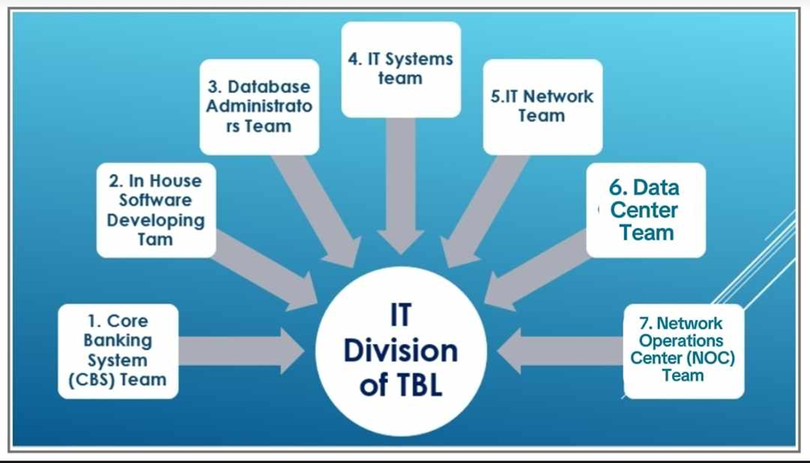

**Figure 1.1: IT Division of TBL**

### **1.2.1 Core Banking System (CBS) Team**

Core Banking is a type of banking service offered by a network of connected bank branches, allowing users to access their accounts and carry out simple financial operations from any of the participating branch locations. Core banking and retail banking are sometimes used interchangeably, and many banks classify their retail consumers as core banking clients. Core banking includes fundamental money lending and depositing. Transaction accounts, loans, mortgages, and payments will all be considered core banking services.

### **1.2.2 In-House Software Development Team**

Based on the needs of the Bank, the in-house software development team creates and customizes the software. Six people work on the internal software team of Trust Bank Limited. For privacy and customization, the internal software team must create some software. The security and privacy of the company's confidential information may be impacted if it is given to vendors.

Trust Bank Ltd. features a private intranet portal with a variety of intra-apps. These are accessible to bank workers and other authorized individuals. The team created more than 68 intra-apps, including the Employee Management System, Intra Message, Loan Approval, Card Process, Card Processing, Remittance Disbursement System and others. The group also creates environments, tests platforms, and testing automation frameworks, and integrates code in accordance with an agile framework.

### **1.2.3 Database Administration Team**

Banks use databases to keep track of customer accounts, balances, and deposits. All databases located at different data center sites have synchronization among them. They have a DRS in Jashore for maintaining the regulation of Bangladesh Bank.

### **1.2.4 IT System Team**

The servers, storage, printers, PCs, and other hardware are all taken care of and kept up to date by the Trust Bank IT Systems team. They organize and maintain this machinery and technology. This can involve the creation and upkeep of build environments, testing platforms, frameworks for testing automation, and continuous integration, as well as the incorporation of code from agile teams. If there was an issue with the computer, the branch only needed to send it to the Head Office.

### **1.2.5 IT Network**

Team Trust Bank’s IT Network team provides all network device installation and troubleshooting support to the branches, and ATMs. This team is also providing connectivity support among head office, branches, and ATMs, which is the most important task to run the banking system.

### **1.2.6 Data Center**

Like most modern organizations, Trust Bank Limited maintains a number of Data Centers (DC, NDC and DR) for data backup and redundancy.

### **1.2.7 Network Operation Center (NOC) Team**

The engineers can monitor the availability and performance of the network and services for 24 ×7 on a roster basis and administer equipment in need of maintenance.

The responsibilities of a NOC are as follows:

• Data center management

• Network monitoring

• IT support

• End Day (EOD) process execution

### **1.2.8 Information Security, Risk & Compliance Department (ISRCD)**

The Information Security Management Team of TBL is responsible for ensuring the confidentiality, integrity, and availability of the bank’s information assets, such as customer data, financial transactions, and intellectual property. Besides, this team conducts Security Awareness Training for the employees of TBL. Such as their computer will lock after 1 minute if not usage.

### **1.2.9 Mission:**

The missions of Trust Bank Ltd. are given below-

* Long-term sustainable growth diversified business with robust risk management.
* Financial inclusion brings the unbanked population into the banking network through low-cost and technology-based service delivery.
* Accountable to all stakeholders- customers, shareholders, employees and regulators.
* Highest level of compliance and transparency at all levels of operations.

### **1.2.10 Vision:**

The vision of Trust Bank Ltd. is to establish a long-term, sustainable financial institution through financial inclusion and provide maximum value to all stakeholders while adhering to the strictest compliance standards.

## Objectives

This internship report is mainly meant for completion of the Bachelor of Science (B.Sc.) degree requirement in Computer Science and Engineering (CSE) inside the Faculty of Science and Technology. The internship program's goal is to allow students to reflect on the advantages and opportunities of their selected job. The internship program is approximately three credit hours and aims to provide students with practical experience in the field of their choice. The internship's primary objective is to introduce students to an actual job environment and offer them with chances to gain new skills, develop their social skills, and gain essential experience. The content of this paper strives to talk about my personal internship experiences and give significant thoughts. The report outlines the following objectives:

• Gain professional environment understanding and the ability to operate in industrial and industrial settings.

• Understanding of how to retain and manage a job for a set period of time.

• Performing and directing work while under pressure.

• To better prepare myself for my future career.

# ACTIVITIES

An internship represents a brief period of employment during which an individual, frequently lacking of prior professional exposure, becomes involved with a company. Its core objectives revolve around build up the intern's comprehension of the industry and providing hands-on, practical experience. The internship gave me the chance to taste the flavor of the career as a Network Engineer in an established bank such as TBL. Collaborating with seasoned professionals at Trust Bank Limited (TBL), I actively participated in maintaining theoretical knowledge on network devices-router, firewall switch etc. VLANs, Inter-VLAN routing, Dynamic routing, and various servers such as DNS, DHCP, and Email. Additionally, I worked on managing GRE Tunnels, swiftly addressing any unexpected challenges that arose.

## Work-Related

During my internship, there were instances where I faced challenges due to tasks that did not directly align with my academic background. One particular situation that stands out is when I was assigned a task involving networking, an area in which I had limited knowledge and experience. As a result, I encountered difficulties completing the task to the best of my abilities.

This particular task required an understanding of VLAN, Inter-VLAN routing, dynamic routing, and GRE Tunnel. Although I possessed a solid foundation in my academic studies, which provided me with a strong theoretical background, the specific knowledge required for this task was beyond the scope of my previous coursework. Consequently, I had to invest extra time and effort to acquire the necessary knowledge and skills to fulfill the assignment requirements.

To overcome this challenge, I took a proactive approach to bridge the gap in my knowledge. I conducted extensive research, delving into scholarly articles and online resources related to networking. I also got guidance from my supervisor and colleagues, who provided valuable insights and assistance throughout the process. I gradually developed a better understanding by leveraging these resources and seeking guidance.

Despite the initial difficulties, this experience presented an invaluable opportunity for academic growth and personal development. It highlighted the importance of adapting and acquiring new knowledge outside the confines of formal education. It taught me the significance of being proactive in expanding my skill set and embracing unfamiliar challenges. Furthermore, it underscored the significance of collaboration and seeking guidance from experts in the field to overcome obstacles and enhance performance.

In retrospect, while encountering tasks that did not directly align with my academic background may have initially posed challenges, it ultimately served as a catalyst for my academic and professional growth. It pushed me to step out of my comfort zone, acquire new knowledge, and develop a more diverse skill set. This experience reinforced the importance of continuous learning and adaptability in an ever-evolving academic and professional landscape.

Whatever, my internship provided me with opportunities to encounter tasks that were not directly aligned with my academic background. However, through research, guidance, and perseverance, I was able to overcome these challenges and acquire the necessary knowledge and skills to complete the task successfully. This experience emphasized the importance of proactive learning, adaptability, and seeking guidance from experts to overcome obstacles and foster personal and academic growth.

IT support team may Engineers with hardware privilege sometimes have to go to branches for major IT support if required. if any hardware (network related) has any issues for example a switch has an issue in a port and needs to be changed etc. As an intern I did not have to go on these field works but I did get briefed as I wanted to know.

Every morning at 10 AM, I participated in meetings with my supervisor to receive instructions regarding my tasks from the previous day, what I have accomplished, what I will do today, and so on. In the afternoon at 5PM I reported on my workload to my supervisor to get his feedback. As a result, I had to arrive at the office on time 5 days in a week. The office was open from 9:00 until 6:00 pm. Friday and Saturday were weekly off days. It was vital to stick to a rigid schedule and maintain discipline while working. The company gave all employees an hour-long lunch break and took steps to keep them motivated and engaged in creating high-quality work.

## Organization Wide

During my internship as an Intern under the guidance of Abdullah Al Masud, I had the opportunity to contribute to the organization in various ways. Firstly, working closely with Vice President, Head office, IT Division like Abdullah Al Masud provided me with valuable insights into the responsibilities and duties of professionals in the field of networking. This experience not only expanded my knowledge but also equipped me with the necessary skills to be an asset to the department.

Additionally, I had the privilege of assisting in a project. This involvement allowed me to gain hands-on experience in the real-life networking, including router configuration and switch configuration for data passing through the router.

I have successfully explored and configured the system according to company requirements, and I completed the project on time. Moreover, the knowledge and skills acquired during this internship position me as a valuable asset, ready to make meaningful contributions to the field of networking.

## Other Relevant Activities

Aside from the works that were given to me time to time also helped out with compliance and relevant paperwork. In any IT that is dedicated to a for any organization compliance is a must. Creating policies and revising them is also very important in order to maintain a secure environment where data breaches may not happen. Also doing compliance work gives an insight on how information security jobs look like and what they do. Having experience with formal writings is also considered a plus point as it will help future work in similar field. My participation in these activities also shown my commitment to produce flawless and error-free application. Finally, I am convinced that the knowledge and experience I have obtained over this period will be useful to me in my future work as a subject matter expert.

# CONSTRAINTS / CHALLENGES

Even through all the achievements and advantages, there is bound to be hardships, I had to face some challenges during my internship period too. But those struggles made me realize my lacking and enlightened me of which parts I should work on and what I should consider important. Joining the IT Network Team has been a source of immense joy, and I'm grateful to have played a role in achieving our collective goals. The fellowship among my colleagues has been truly heartening. They have been incredibly supportive, offering guidance whenever I faced challenges, which has significantly eased my transition into this new role. I'm looking forward to continued growth and collaboration within this dynamic team.

## Identified / Observed in the organization

Since this was my first internship, I was quite appreciative of the opportunity to learn a lot. I was rather anxious about adjusting to a brand-new workplace on my first day. TBL is a renowned organization and the environment was equally amazing everyone was quite friendly and helpful. I was thoroughly briefed on the theoretical aspect of the network infrastructure and how it was established. But still some level of exposure would have been a great experience for someone who is about to step in the job sector. It would have been greatly helpful if I was able to access more of the officer workloads and got to work as part of the organization. Also, my second month in the organization was cut short due to the strikes and I was not able to commute to my workplace as a result I was not able to fully utilize my caliber. Thus, I was not able to see any of the new devices being configured which I thought was a very important aspect of my internship. Overall, a lot of issues came to be when I started my internship but no path is without its thorns and going forward by overcoming them gives us strength so, I sought whatever knowledge I could get my hands on and tried my best to make this internship worthwhile and I will say that it was still worth the time spent and effort given as it showed me the world I am about to step in and gave me the courage to work though the hardships and move forward by improving myself.

## Academic Preparation

There lies a vast difference in working in a simulated environment and working in real-time. I encountered challenges during my internship, particularly in tasks outside my academic background. Despite initial difficulties, I proactively bridged the knowledge gap through extensive research, seeking guidance, and leveraging available resources. This experience emphasized the importance of adaptability, proactive learning, and collaboration, ultimately contributing to my academic and professional growth.

## Personal and Professional Skills Development

This was my first time working in an actual corporate organization so I was a bit at a loss in communicating with the officers and sometimes found myself at a loss. So, I had to improve my teamwork. Even though I have teamwork experience during various projects throughout my university life, this time I had the chance to experience it in a larger scope and truly understand the importance of teamwork. An organization as big as trust needs sufficient team work to run properly as no one alone can deal with all the problems that are being presented so a mutual understanding of workload sharing and assistance is needed. This helps the organization keep its work done within its tight schedule. Also, as a network engineer a lot of courses need to be done in order to understand the infrastructure that I lacked. After consulting with my organizational supervisor, I was able to navigate through my lacking and was guided to what I should learn and what courses I should take if I wanted to build my career as a network engineer and be good at the work.

# 4. Project Work

## 4.1 Project Overview

I have created a generic banking network infrastructure by using the Cisco packet tracer as well as in real life network devices. The project aims to create a secure, efficient, and interconnected banking network infrastructure. We're achieving this by using dynamic routing, VLANs, GRE Tunnels, and servers. This forms a strong foundation for an adaptable banking network, improving operational efficiency and ensuring security in the banking environment.

In this infrastructure the activities that I have done are given below:

* Firstly, I have connected the Head Office, CTG Branch and Bogura Branch via ISP-1 and ISP-2 for passing data packets among them. I have used the Dynamic routing protocol for efficient data packet transmission.
* Then successfully passing data among the entire network, I have created 5 VLANs (Virtual Local Area Networks) in the Head Office’s LAN network for improved network segmentation. These are- VLAN 10, 20, 11, 100 and 200.
* After that, in order to communicate the VLANs among each other I have done the Inter-VLAN routing activity in the Head Office’s router.
* After the VLANs compilation, I have created the GRE Tunnel among the branches and the Head Office as well as between the Head Office and the Branch against the ISP-1 in order to pass the data packets securely.
* Moreover, I have added another ISP as an alternative way if any ISP-1 will face any problem. In the ISP-2, I have created the GRE Tunnel against ISP-2 between the Branch (ATM) - Head Office and Head Office - Branch again to send data securely.
* Deployed 7 Servers in the Head Office’s. LAN network. These are:

1. DNS (Domain Name System)
2. DHCP (Dynamic Host Configuration Protocol)
3. CBS (Core Banking System)
4. Email
5. iBanking
6. WWW (Web)
7. FTP (File Transfer Protocol)

* Enabled DHCP for automatic IP address assignment across the Head Office's network.
* Established email services at CTG Branch, Head Office, and Bogura Branch to enhance communication.
* Enabled websites on the WWW server for viewing webpages.
* Finally, added login features to CBS and iBanking Servers for account access using usernames and passwords.

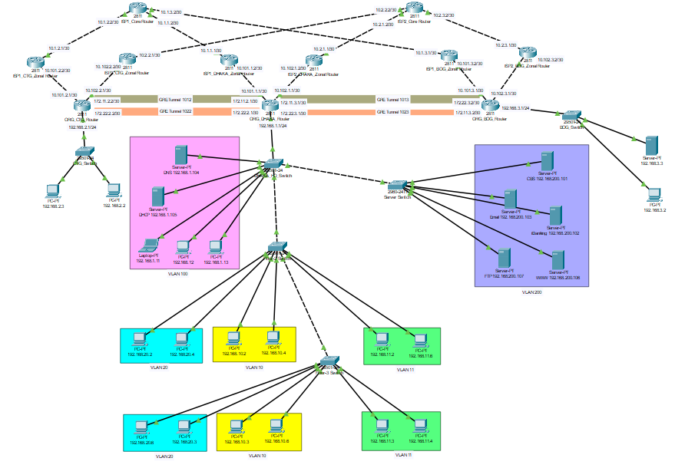**Topology of the Banking Network:**

**Figure 4.1: Enterprise Network for banking services using Cisco Packet Tracer**

## 4.2 Topology Table

**Topology table for Head Office:**

|  |  |  |  |  |  |
| --- | --- | --- | --- | --- | --- |
| **Source Device** | **Source Port** | **IP** | **Destination Device** | **Destination Port** | **IP** |
| ISP-1 Core Router | Fa 0/1 | 10.1.1.2 | ISP-1 Dhaka  Zonal router | Fa 0/1 | 10.1.1.1 |
| ISP-2 Core Router | Fa 0/1 | 10.2.1.2 | ISP-2 Dhaka  Zonal router | Fa 0/1 | 10.2.1.1 |
| ISP-1 Dhaka Zonal Router | Fa 0/0 | 10.101.1.2 | ORG H.O Router | Fa 0/1 | 10.101.1.1 |
| ISP-2 Dhaka Zonal Router | Fa 0/0 | 10.102.1.2 | ORG H.O Router | Eth 1/0 | 10.102.1.1 |

**Table 4.1: Routing table of Head Office**

|  |  |  |  |  |
| --- | --- | --- | --- | --- |
| **Source Device** | **Source Port** | **Destination**  **Device** | **Destination**  **Port** | **Connection**  **Type** |
| Dhaka HO Switch (Floor-1) | Gig 0/2 | ORG Dhaka Router | Fa 0/0 | Access |
| Dhaka HO Switch | Fa 0/24 | Server Switch | Fa 0/4 | Trunk |
| Dhaka HO Switch | Gig 0/1 | Floor-2 Switch | Gig 0/1 | Trunk |
| Floor-2 Switch | Gig 0/2 | Floor-3 Switch | Gig 0/2 | Trunk |

**Table 4.2: Switchport types of Head Office Switch**

|  |  |  |  |  |
| --- | --- | --- | --- | --- |
| **Source Device** | **Source Port** | **Destination**  **Device** | **Destination**  **Port** | **IP Address (DHCP Enabled)** |
| Dhaka HO Switch (Floor-1) | Fa 0/1 | PC | Fa 0 | 192.168.1.13 |
| Dhaka HO Switch (Floor-1) | Fa 0/5 | PC | Fa 0 | 192.168.1.12 |
| Dhaka HO Switch (Floor-1) | Fa 0/2 | Laptop | Fa 0 | 192.168.1.11 |

**Dhaka Head Office Switch:**

**Table 4.3: IP Configuration of Dhaka Head Office Switch**

**Floor-2 Switch:**

|  |  |  |  |  |
| --- | --- | --- | --- | --- |
| **Source Device** | **Source Port** | **Destination**  **Device** | **Destination**  **Port** | **IP Address (DHCP Enabled)** |
| Floor-2 Switch | Fa 0/1 | PC | Fa 0 | 192.168.20.2 |
| Floor-2 Switch | Fa 0/2 | PC | Fa 0 | 192.168.20.4 |
| Floor-2 Switch | Fa 0/11 | PC | Fa 0 | 192.168.10.2 |
| Floor-2 Switch | Fa 0/12 | PC | Fa 0 | 192.168.10.4 |
| Floor-2 Switch | Fa 0/22 | PC | Fa 0 | 192.168.11.2 |
| Floor-2 Switch | Fa 0/23 | PC | Fa 0 | 192.168.11.6 |

**Table 4.4: IP Configuration of Floor-2 Switch**

|  |  |  |  |  |
| --- | --- | --- | --- | --- |
| **Source Device** | **Source Port** | **Destination**  **Device** | **Destination**  **Port** | **IP Address (DHCP Enabled)** |
| Floor-3 Switch | Fa 0/1 | PC | Fa 0 | 192.168.20.6 |
| Floor-3 Switch | Fa 0/2 | PC | Fa 0 | 192.168.20.3 |
| Floor-3 Switch | Fa 0/11 | PC | Fa 0 | 192.168.10.3 |
| Floor-3 Switch | Fa 0/12 | PC | Fa 0 | 192.168.10.6 |
| Floor-3 Switch | Fa 0/22 | PC | Fa 0 | 192.168.11.3 |
| Floor-3 Switch | Fa 0/23 | PC | Fa 0 | 192.168.11.4 |

**Floor-3 Switch:**

**Table 4.5: IP Configuration of Floor-3 Switch**

**Topology table for CTG:**

|  |  |  |  |  |  |
| --- | --- | --- | --- | --- | --- |
| **Source Device** | **Source Port** | **IP** | **Destination Device** | **Destination Port** | **IP** |
| ISP-1 Core Router | Fa 0/0 | 10.1.2.2 | ISP-1 CTG  Zonal router | Fa 0/1 | 10.1.2.1 |
| ISP-2 Core Router | Fa 0/0 | 10.2.2.2 | ISP-2 CTG  Zonal router | Fa 0/1 | 10.2.2.1 |
| ISP-1 CTG Zonal Router | Fa 0/0 | 10.101.2.2 | ORG CTG Router | Fa 0/1 | 10.101.2.1 |
| ISP-2 CTG Zonal Router | Fa 0/0 | 10.102.2.2 | ORG CTG Router | Eth 1/0 | 10.102.2.1 |

**Table 4.6: Routing table of CTG Branch**

|  |  |  |  |  |
| --- | --- | --- | --- | --- |
| **Source Device** | **Source Port** | **Destination Device** | **Destination Port** | **Connection Type** |
| CTG Switch | Fa 0/3 | CTG Router | Fa 0/0 | Access |

**Table 4.7: Switchport types of CTG Switch**

**CTG Switch:**

|  |  |  |  |  |
| --- | --- | --- | --- | --- |
| **Device** | **Source Port** | **Destination Device** | **Destination Port** | **IP Address** |
| CTG Switch | Fa 0/1 | PC | Fa 0 | 192.168.2.3 |
| CTG Switch | Fa 0/2 | PC | Fa 0 | 192.168.2.2 |

**Table 4.8: IP Configuration of CTG Switch**

**Topology table for BOG:**

|  |  |  |  |  |  |
| --- | --- | --- | --- | --- | --- |
| **Source Device** | **Source Port** | **IP** | **Destination**  **Device** | **Destination**  **Port** | **IP** |
| ISP-1 Core Router | Eth 1/0 | 10.1.3.2 | ISP-1 Bogura  Zonal router | Fa 0/1 | 10.1.3.1 |
| ISP-2 Core Router | Eth 1/0 | 10.2.3.2 | ISP-2 Bogura  Zonal router | Fa 0/1 | 10.2.3.1 |
| ISP-1 Bogura Zonal Router | Fa 0/0 | 10.101.3.2 | ORG Bogura Router | Fa 0/1 | 10.101.3.1 |
| ISP-2 Bogura Zonal Router | Fa 0/0 | 10.102.3.2 | ORG Bogura Router | Eth 1/0 | 10.102.3.1 |

**Table 4.9: Routing table of Bogura Branch**

|  |  |  |  |  |
| --- | --- | --- | --- | --- |
| **Device** | **Source Port** | **Destination Device** | **Destination Port** | **Connection Type** |
| BOG Switch | Fa 0/2 | BOG Router | Fa 0/0 | Access |

**Table 4.10: Switchport types of Bogura Switch**

|  |  |  |  |  |
| --- | --- | --- | --- | --- |
| **Device** | **Source Port** | **Destination Device** | **Destination Port** | **IP Address** |
| BOG Switch | Fa 0/3 | PC | Fa 0 | 192.168.3.2 |
| BOG Switch | Fa 0/1 | Server | Fa 0 | 192.168.3.3 |

**BOG Switch:**

**Table 4.11: IP Configuration of Bogura Switch**

**IP Planning:**

**IP planning for Head Office:**

|  |  |  |
| --- | --- | --- |
| **Department** | **VLAN ID** | **IP Planning** |
| Admin | VLAN-100 | 192.168.100.0 / 24 |
| Server | VLAN-200 | 192.168.200.0 / 24 |
| HR | VLAN-20 | 192.168.20.0 / 24 |
| IT | VLAN-10 | 192.168.10.0 / 24 |
| Finance | VLAN-11 | 192.168.11.0/24 |

**Table 4.12:** **VLAN Networks**

|  |  |  |
| --- | --- | --- |
| **Network Segment** | **IP Planning** | **Remarks** |
| ISP - 1 | 10.1.1.0 /30 | ISP Connectivity |
| ISP - 2 | 10.2.1.0 /30 | ISP Connectivity |
| ISP - 1 Zonal Router | 10.101.1.0 /30 | ISP Connectivity |
| ISP - 2 Zonal Router | 10.102.1.0 /30 | ISP Connectivity |
| Tunnel 1012 | 172. 11.2.1/ 30 | Head Office – CTG (ISP-1) |
| Tunnel 1022 | 172.22.2.1 / 30 | Head Office – CTG (ISP-2) |
| Tunnel 1013 | 172.11.3.1/ 30 | Head Office – BOG (ISP-1) |
| Tunnel 1023 | 172.22.3.1 / 30 | Head Office – BOG (ISP-2) |

**Table 4.13: Network Segments for Head Office**

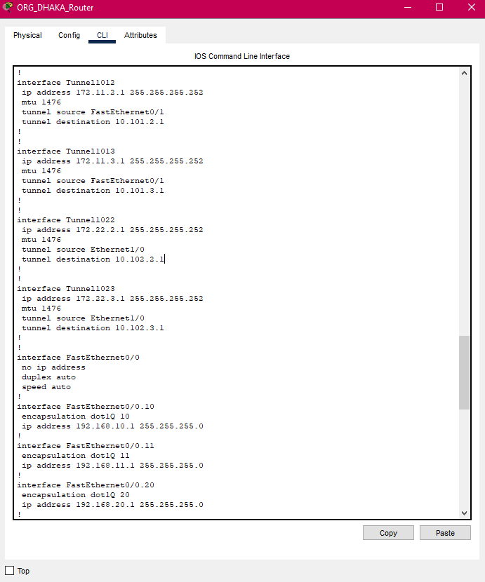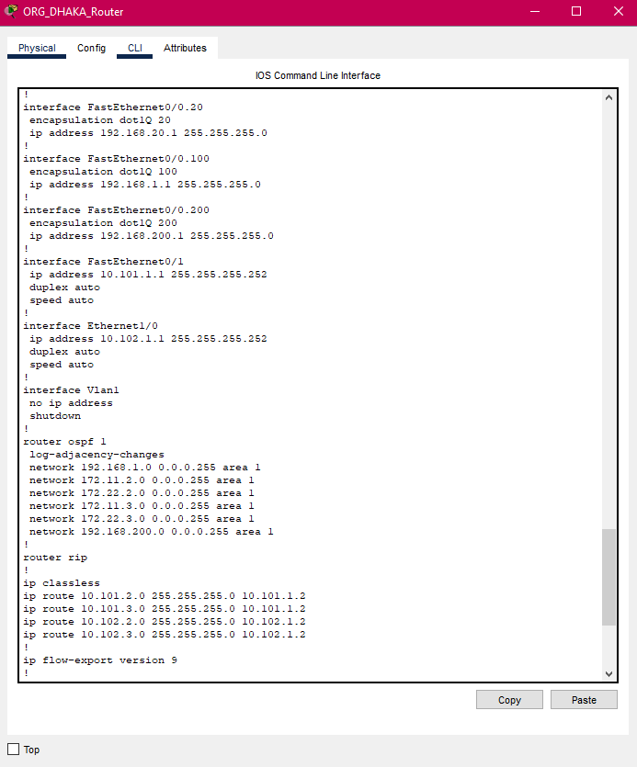

**Figure 4.2: GRE Tunnel and OSPF configuration in ORG Dhaka Router**

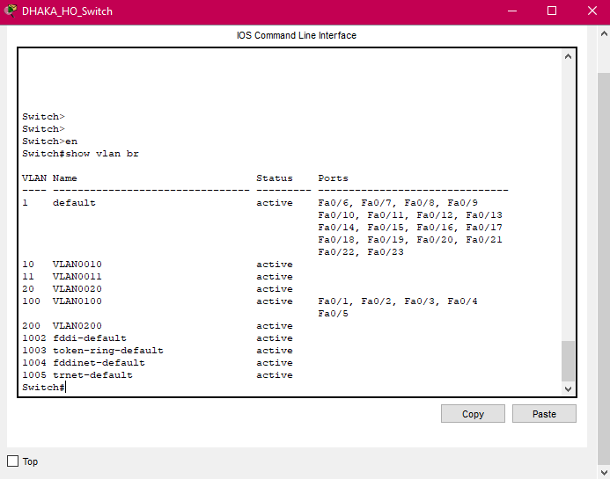

**Figure 4.3: VLAN configuration in Dhaka Head-Office switch**

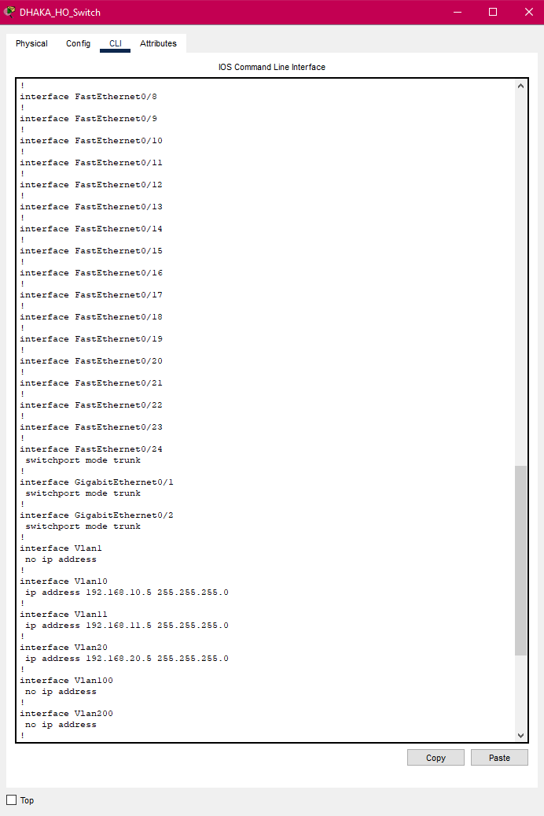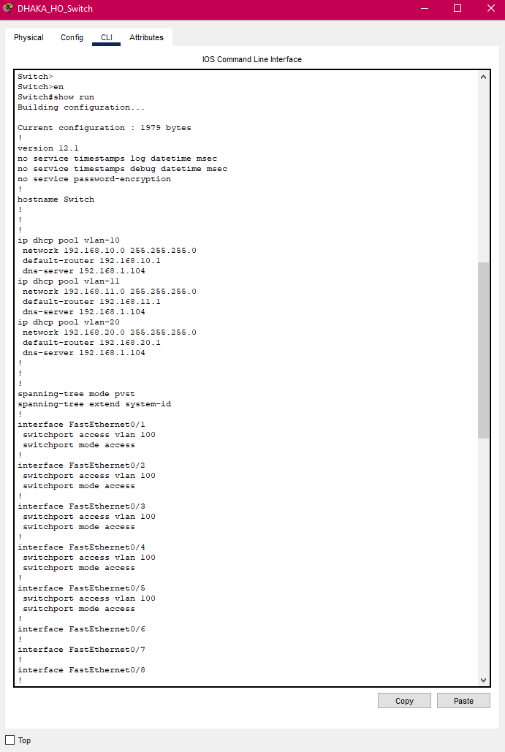

**Figure 4.4: DHCP pool and IP configuration in Dhaka Head-Office switch**

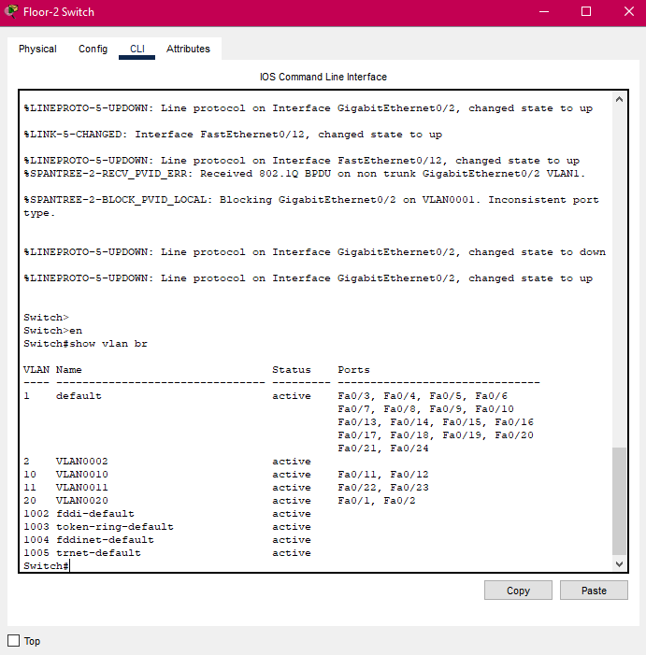

**Figure 4.5: VLAN configuration in Floor-2 switch**

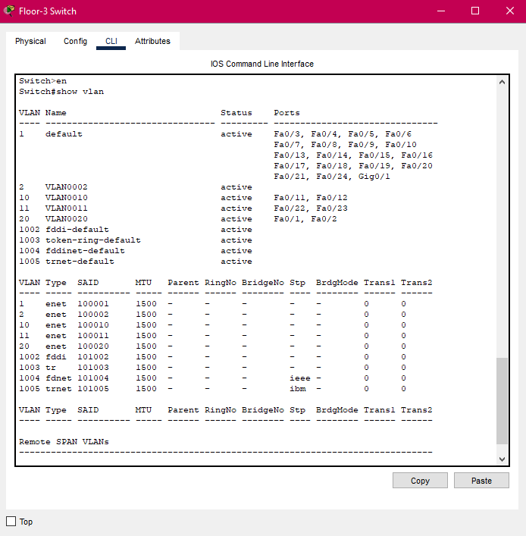

**Figure 4.6: VLAN configuration in Floor-3 switch**

**IP planning for CTG:**

|  |  |  |
| --- | --- | --- |
| **Network Segment** | **IP Planning** | **Remarks** |
| ISP - 1 | 10.1.2.0 / 30 | ISP Connectivity |
| ISP - 2 | 10.2.2.0 / 30 | ISP Connectivity |
| ISP -1 Zonal Router | 10.101.2.0 /30 | ISP Connectivity |
| ISP - 2 Zonal Router | 10.102.2.0 /30 | ISP Connectivity |
| CTG Network | 192.168.2.0 / 24 | LAN Connectivity |
| Tunnel 1012 | 172.11.2.2 / 30 | CTG – Head Office (ISP-1) |
| Tunnel 1022 | 172.22.2.2 / 30 | CTG – Head Office (ISP-2) |

**Table 4.14: Network Segments for CTG Branch**

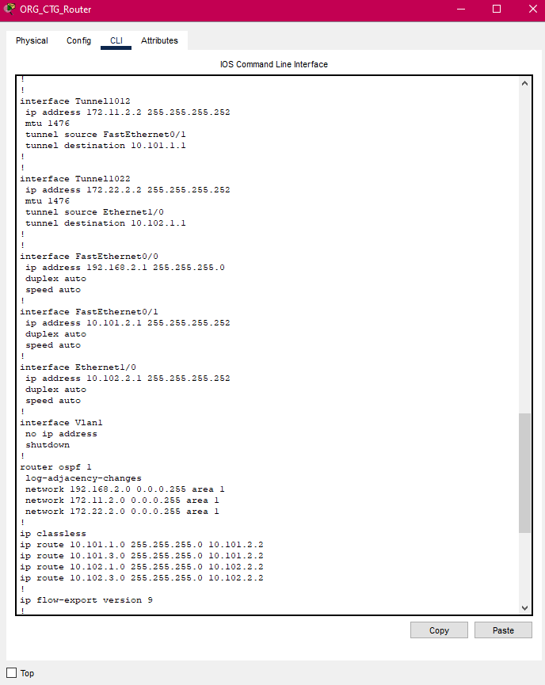

**Figure 4.7: GRE Tunnel and OSPF configuration in ORG CTG Router**

**IP planning for BOG:**

|  |  |  |
| --- | --- | --- |
| **Network Segment** | **IP Planning** | **Remarks** |
| ISP - 1 | 10.1.3.0 / 30 | ISP Connectivity |
| ISP - 2 | 10.2.3.0 / 30 | ISP Connectivity |
| ISP -1 Zonal Router | 10.101.3.0 /30 | ISP Connectivity |
| ISP - 2 Zonal Router | 10.102.3.0 /30 | ISP Connectivity |
| CTG Network | 192.168.3.0 / 24 | LAN Connectivity |
| Tunnel 1013 | 172.11.3.2 / 30 | BOG – Head Office (ISP-1) |
| Tunnel 1023 | 172.22.3.2 / 30 | BOG – Head Office (ISP-2) |

**Table 4.15: Network Segments for Bogura Branch**

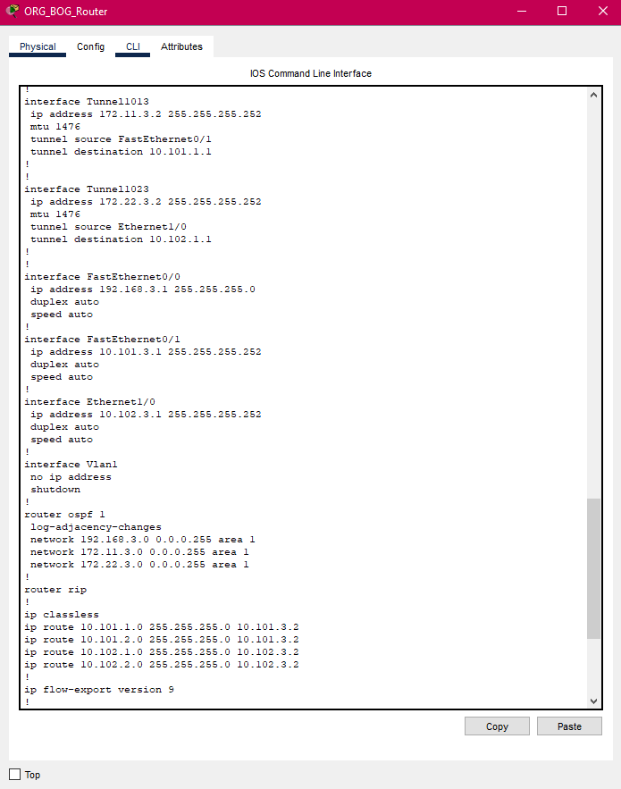

**Figure 4.8: GRE Tunnel and OSPF configuration in ORG BOG Router**

|  |  |  |  |  |
| --- | --- | --- | --- | --- |
| **Source Device** | **Source Port** | **Destination**  **Device** | **Destination**  **Port** | **IP Address** |
| Server Switch | Fa 0/2 | CBS | Fa 0 | 192.168.200.101 |
| Server Switch | Fa 0/1 | Email | Fa 0 | 192.168.200.103 |
| Server Switch | Fa 0/10 | iBanking | Fa 0 | 192.168.200.102 |
| Server Switch | Fa 0/8 | WWW | Fa 0 | 192.168.200.106 |
| Server Switch | Fa 0/6 | FTP | Fa 0 | 192.168.200.107 |
| Dhaka HO Switch (Floor-1) | Fa 0/4 | DNS | Fa 0 | 192.168.1.104 |
| Dhaka HO Switch (Floor-1) | Fa 0/3 | DHCP | Fa 0 | 192.168.1.105 |

**Topology table for Servers:**

**Table 4.16: IP Configuration of Servers**

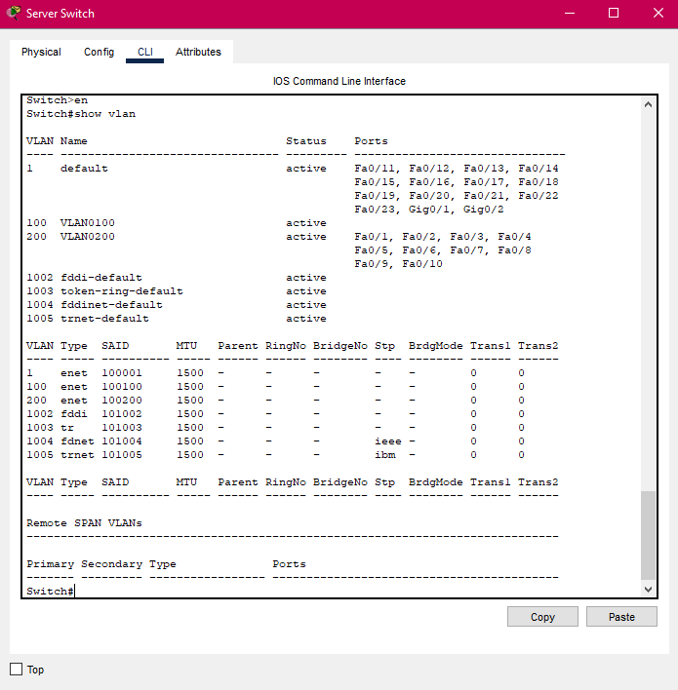

**Figure 4.9: VLAN configuration in Server switch**

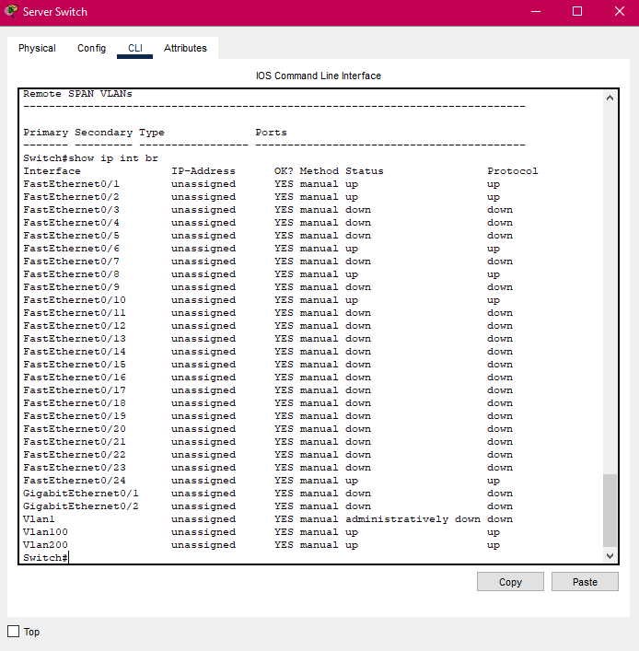

**Figure 4.10: IP configuration in Server switch**

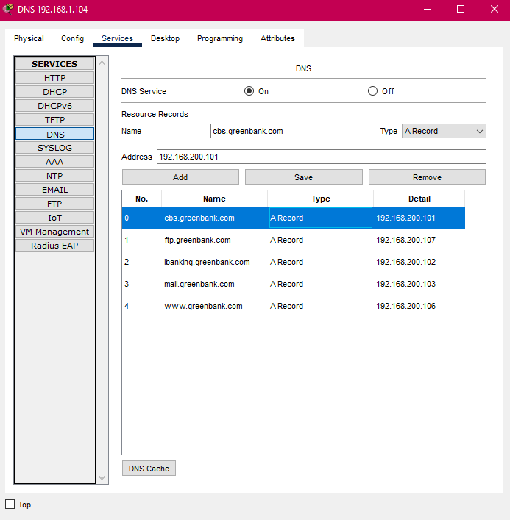

**Figure 4.11: DNS**

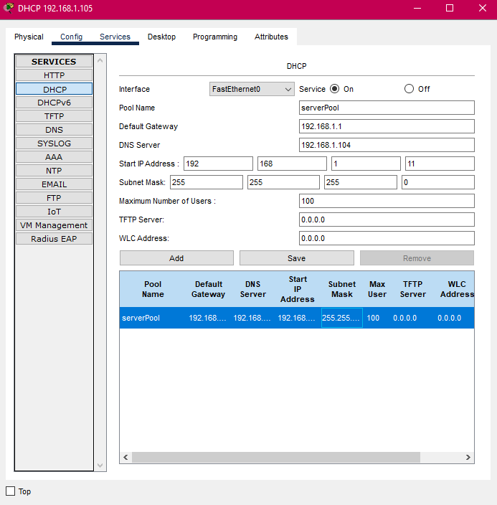

**Figure 4.12: DHCP**

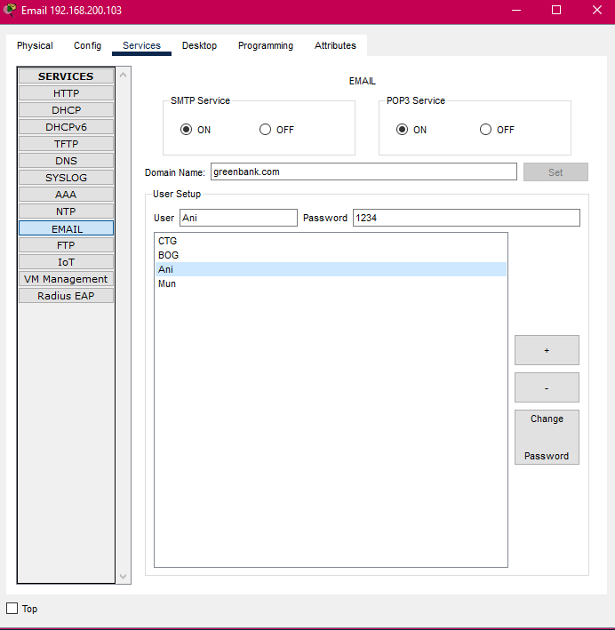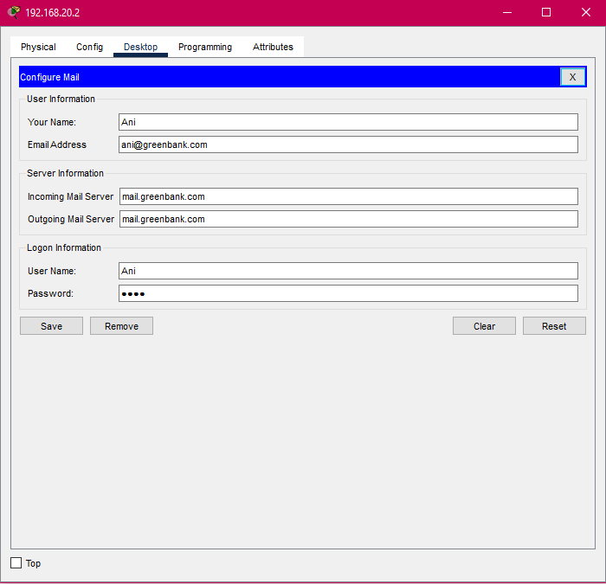

**Figure 4.13: Email Configuration**

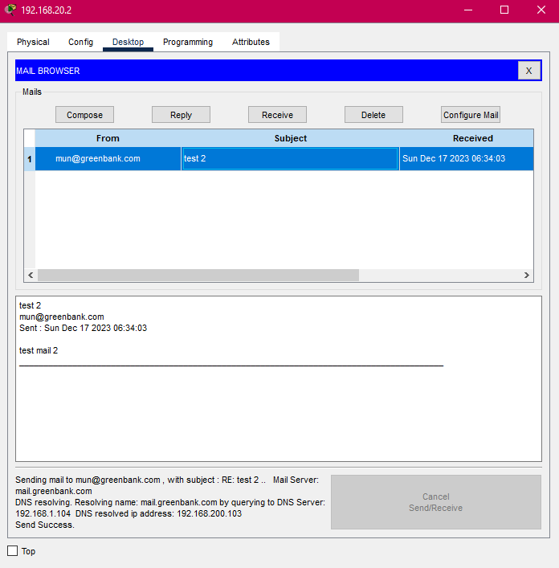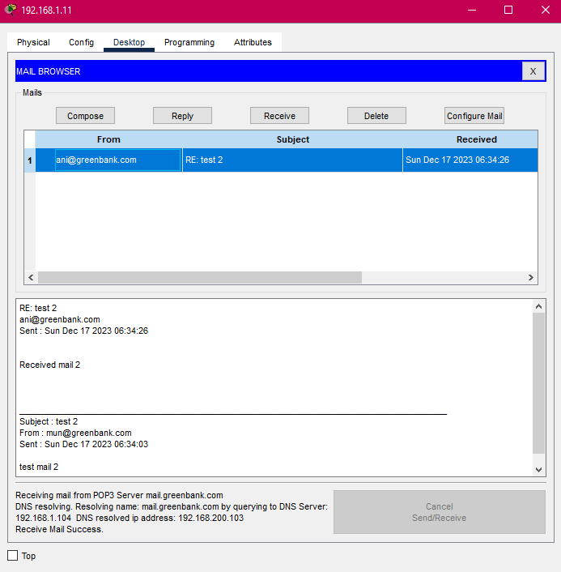

**Figure 4.14: Send and Receive Mail Success**

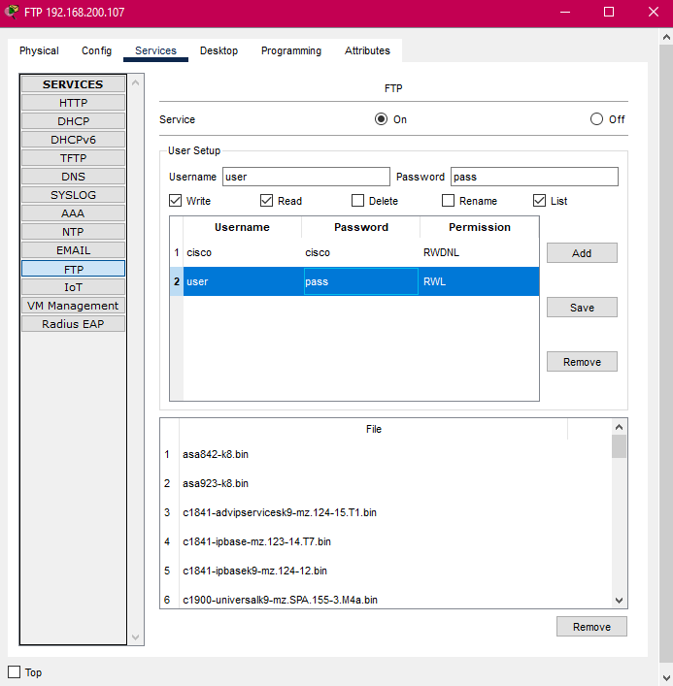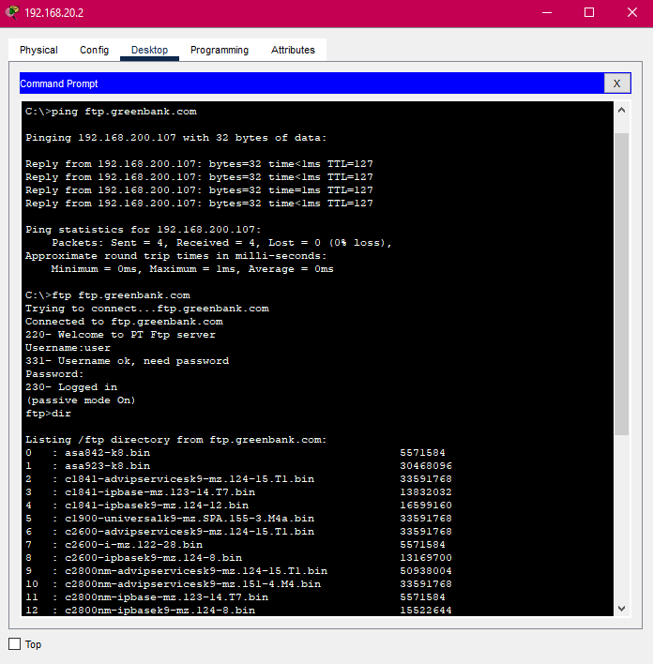

**Figure 4.15: FTP**

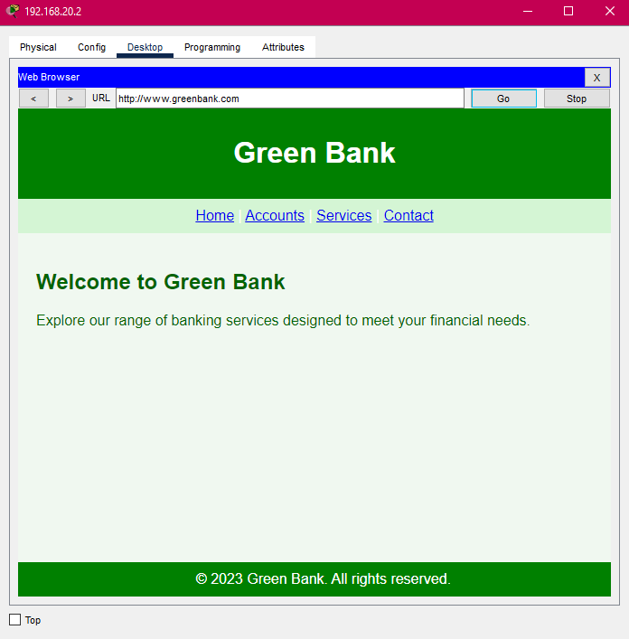

**Figure 4.16: Web Page for Green Bank**

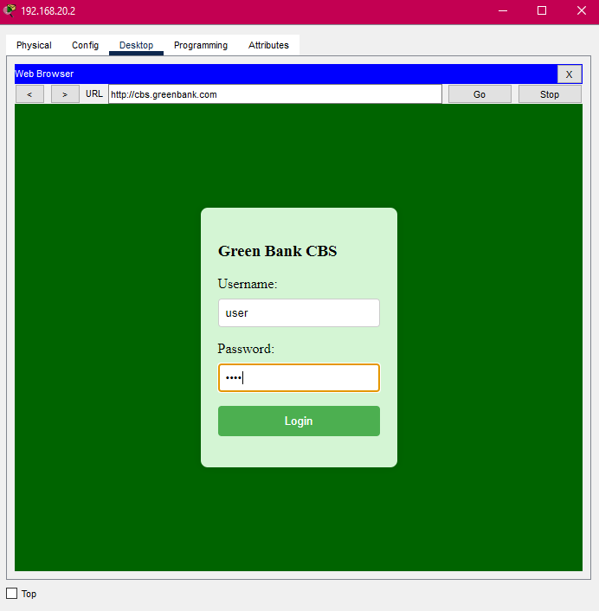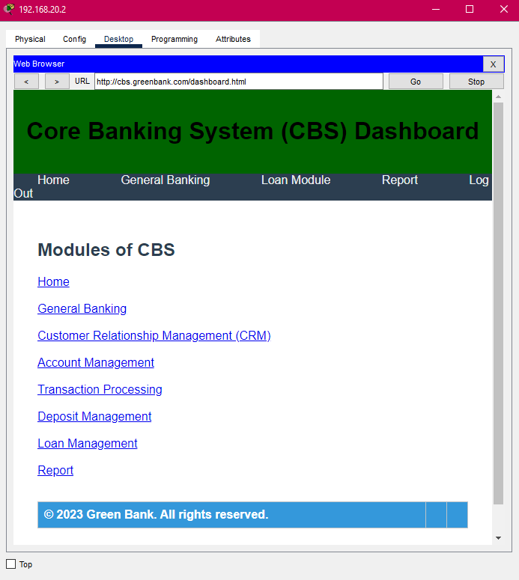

**Figure 4.17: CBS Login**

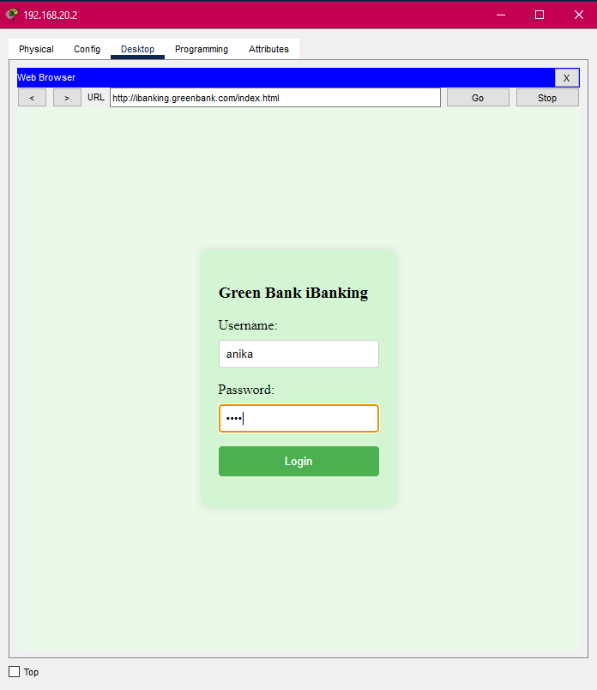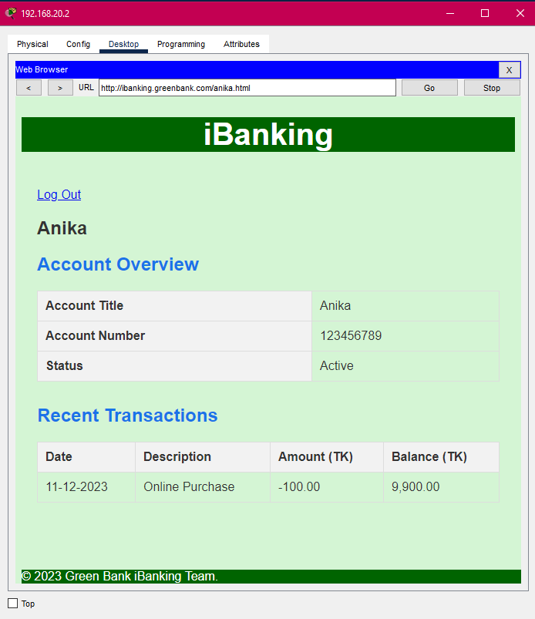

**Figure 4.18: iBanking Login**

## 4.3 Testing Connectivity

Connection and GRE Tunnel are being checked by using command prompt. Here, the connection between Head Office – CTG Branch and Head Office – Bogura Branch; where packets are sent through tunnel 1012 and tunnel 1013 are being showed.

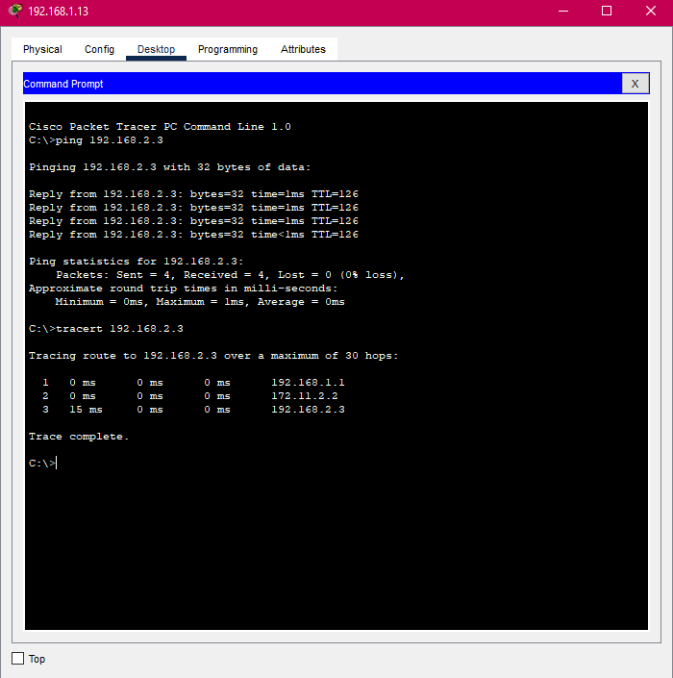

**Figure 4.19: Head Office and CTG connection**

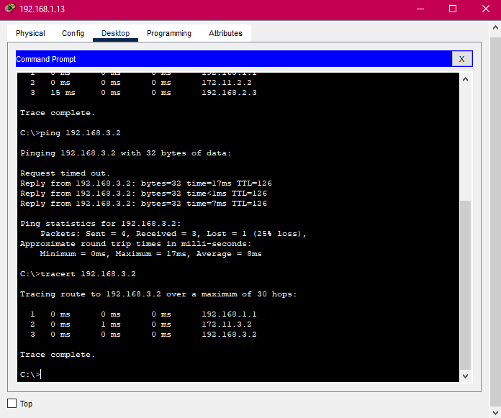

**Figure 4.20: Head Office and Bogura connection**

Now, the connection between CTG Branch - Head Office where packets are sent through tunnel 1012 and CTG Branch – Bogura Branch where packets are sent through tunnel 1012 and tunnel 1013 are being showed.

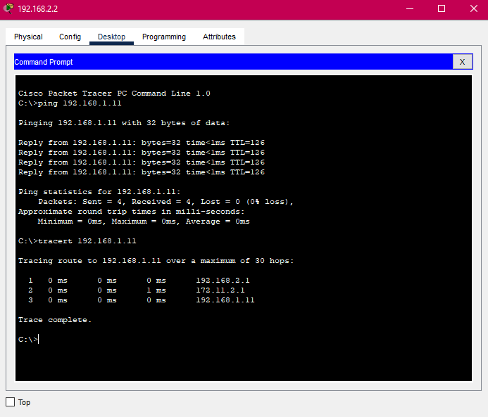

**Figure 4.21: CTG and Head Office connection**

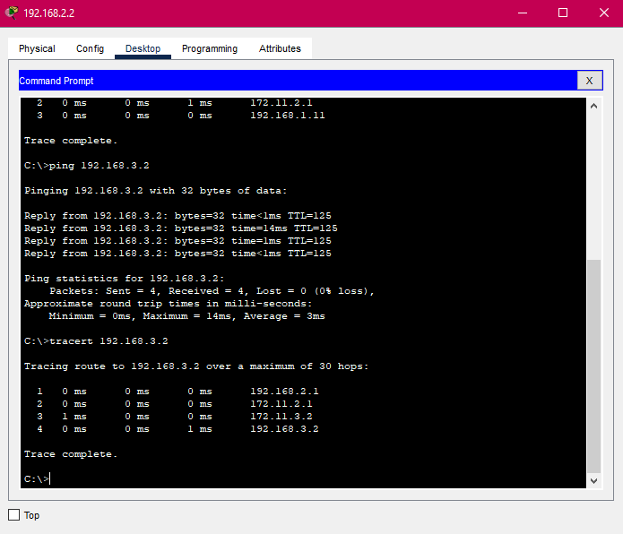

**Figure 4.22: CTG and Bogura connection**

The connection between Bogura Branch- Head Office where packets are sent through tunnel 1013 and Bogura Branch – CTG Branch where packets are sent through tunnel 1012 and tunnel 1013 are being showed here.

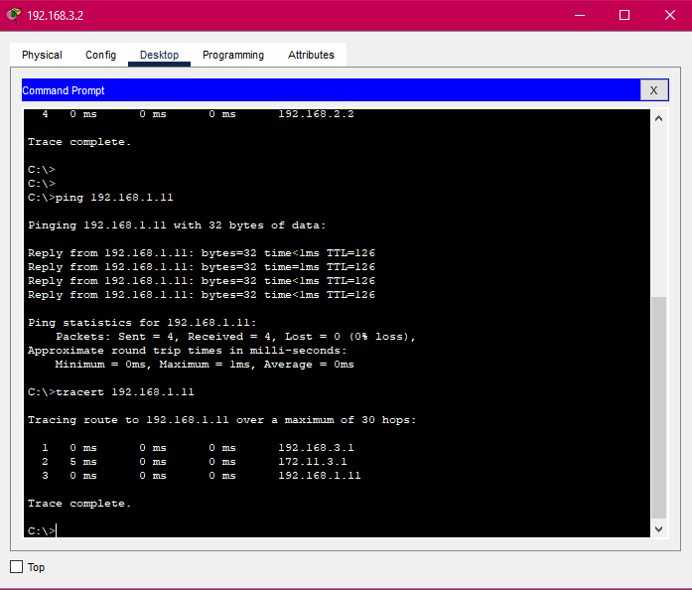

**Figure 4.23: Bogura and Head Office connection**

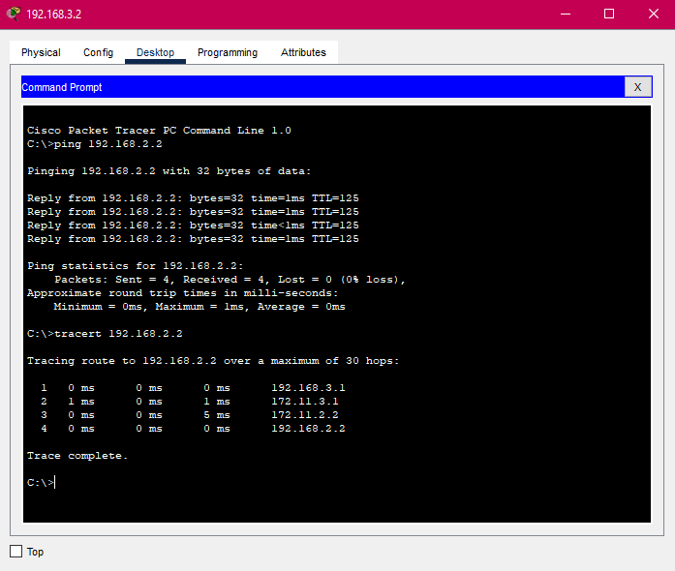

**Figure 4.24: Bogura and CTG connection**

## 4.4 Future Scope

* **Integration of Data Security Protocols:**

To enhance the security of data transmission within the network, the integration of data security protocols is a crucial consideration. IPSec (Internet Protocol Security) can be implemented to ensure the confidentiality, integrity, and authenticity of data. IPSec provides a secure framework for communication, especially in scenarios where sensitive information is being transferred. This addition will contribute significantly to the overall security posture of the network.

* **Implementation of Firewall Configurations:**

To fortify the network against unauthorized access and potential cyber threats, the incorporation of firewall configurations is highly recommended. Firewalls act as a barrier between the internal network and external entities, monitoring and controlling incoming and outgoing network traffic. By defining and implementing firewall rules, the network can be safeguarded against malicious activities and ensure that only legitimate traffic is allowed. Configuring firewalls is an essential step towards achieving a robust and secure network infrastructure.

* **Implementation of Redundancy and High Availability:**

Consider deploying redundancy and high availability solutions for critical servers such as DNS, DHCP, CBS, Email, and iBanking. This ensures continuous operation and minimizes downtime in case of hardware failures or unexpected issues.

* **Implementation of Monitoring and Management Tools:**

Deploy server monitoring and management tools to proactively identify issues, monitor performance metrics, and manage server resources effectively. This can enhance the overall reliability and efficiency of the server infrastructure.

* **Disaster Recovery Planning:**

Develop a comprehensive disaster recovery plan to address potential data loss scenarios. This involves regular backups, offsite storage, and a well-defined recovery process for critical servers like Core Banking System (CBS) to ensure business continuity.

# 5. CONCLUDING STATEMENTS

## 5.1 Summary

During my internship with the company Trust Bank Limited I was able to broaden my understanding of networking and make a major contribution as a Network Engineer. Through practical labor I made an important contribution to the company as a Network Engineer. I attained a better knowledge of the collaborative nature of IT projects and the significance of meticulous planning. This experience increased my confidence. Given the importance of technology in today’s environment, it is critical that our country is focusing on establishing a skilled technological worker force. I hope that my report will provide students and new graduates who are interested in pursuing a career in these fields with relevant information. I hope that sharing my experiences, I might help others who are in similar situations. Throughout my internship, I was able to acquire and improve a variety of abilities that I believe will help me in my future career.

## 5.2 Recommendations/Suggestions for future strategic actions

Students who are interested in a career in networking find difficulties acquiring practical experience in our country. To solve this, universities have implemented internship programs that bridge the gap between academic credentials and industry needs. Companies increasingly prefer skilled workers over those with only well academic achievements in today’s competitive job market. While books help students improve their academics, they may not teach them the necessary industry skills. Many students struggle to find their first job after graduation due to a lack of work experience. Internship programs greatly improve their employability. Companies gain from this symbiotic relationship by teaching interns who may eventually transfer into important permanent roles.

### **5.2.1 Organization**

I recommend numerous ways for maximizing the organizations future activities based on my internship experience, where I mostly functioned as a Network Engineer. Encouraging cross-departmental collaboration improves communication. Investing in continual training keeps the workforce relevant on the latest technologies, giving them a competitive advantage.

### **5.2.2 University**

Universities should take an active role in organizing Internship programs for students to get practical experience. This includes collaborating with other companies and encouraging students to experiment. Opportunities for employment outside of the university context. Organizing on-campus employment fairs is a good strategy. Where companies can engage with graduating students. This model is common in industrialized countries, encourages university-business collaboration, and funds research and development. Companies hire students as part of their growth strategies. Universities must constantly monitor students' true participation in internships to ensure meaningful learning experiences rather than just grade compliance. However, a typical disadvantage of many internship programs is their short duration, which is often limited to three months. This time constraint makes it difficult for students to dive deeply into projects and develop a thorough understanding of real-world problems.

Universities should be aware of this limitation to expand internship lengths or provide alternatives to guarantee students gain significant hands-on practical experience. While a three-month internship provides a taste of the professional world, a longer duration would allow students to work on more difficult projects, manage the hurdles of long-term initiatives, and see their efforts.

Universities must go beyond to actively monitor students' engagement in internship programs to ensure their effectiveness. This includes evaluating the quality of their learning experiences, the relevance of learned skills, and the amount to which internships contribute to their overall professional growth. Universities can better prepare students for the difficulties and opportunities that await them in the workforce by stressing meaningful learning above grade conformity.

### **5.2.3 Personal/Professional**

Participating in professional meetings with team members and colleagues has aided my personal and professional development substantially. I've improved my communication, teamwork, and active listening abilities. Participation in decision-making talks increased my analytical thinking, and participation in problem-solving discussions strengthened those skills. Through contacts with colleagues from various teams, I've become more aware of professional manners, improved time management, and increased my network. Overall, this experience has aided in the development of my professional behavior and the promotion of holistic growth in the workplace.

# 6. RECOMMENDATION LETTER



# 7. REFERENCES

1. Trust Bank Limited - <https://www.tblbd.com/>

2. American International University-Bangladesh - <https://www.aiub.edu/>

3. https://ibanking.tblbd.com/IB/Login/Login.aspx

4. https://www.tblbd.com/trust-money-apps

5. https://en.wikipedia.org/wiki/Trust_Bank_Limited_(Bangladesh)

6. https://en.wikipedia.org/wiki/Packet_Tracer

7. https://www.geeksforgeeks.org/what-is-cisco-packet-tracer/